# Lesson 4 – Spatial Analysis Methods

## THIESSEN POLYGONS

The Thiessen tool can proportionally divide and distribute a point coverage into regions known as **Thiessen or Voronoi polygons**. The polygons are formed by the perpendicular bisectors of the lines joining nearby stations. Each polygon shows the nearest neighbour area around its point. Each Thiessen polygon contains only a single point input feature. Any location within a Thiessen polygon is closer to its associated point than to any other point input feature.

* Create a Thiessen Polygons around the underground stations. The resulting Voronoi diagram can serve as a simple catchment area analysis, or in other words, it can show from which locations it is most likely to visit an underground station.

1. Go to the *Analysis* tab to CLICK on *Tools* . The *Geoprocessing* pane will open.
2. Search for the *Create Thiessen Polygons* tool and open it.
3. SELECT *underground_stations* as *Input Feature* and CHOOSE a name and folder for the *Output Feature Class.*
4. CLICK on the *Output Fields* option dropdown arrow to SELECT *All fields*. This way attribute information on the underground stations will be added to the Thiessen polzgons (the attribute information was added in Lesson 1).
5. CLICK *Run* to execute the tool.
6. CLICK a newly created polygon on the *Map*. By opening the **Pop-up** you should be able to see the attribute underground station information for each polygon.

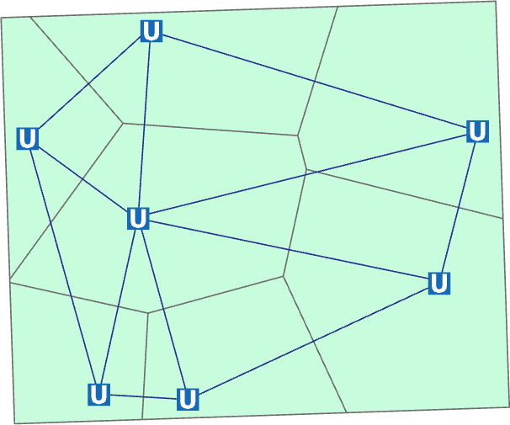

(the geometry of your individual result will probably look slightly different and will be without the blue-lined Delaunay triangulation)

## BUFFER ANALYSIS

Buffer Analysis is a basic GIS spatial operation. It automatically builds zones with a certain width around point, line, or polygon geometric objects according to a specified buffer distance.

* All analysis and distance calculations can be performed regardless of the coordinate system. However, the results may be inaccurate or even meaningless when your data is in a geographic coordinate system or an improperly selected projected coordinate system. Distance measurements will be most accurate when input data is in an equidistance projected coordinate system. In our case, we have a locally projected coordinate system that is not equidistant. However, the distance distortions are rather small in this local UTM stripe and, therefore, insignificant for the following analyses.
* Create a buffer of 50 m around the main streets of the study area. Therefore, you must first select the main streets in order to define a buffer radius around these features.

1. SELECT the main road features by using the *Select by Attribute* tool. You should select all *roads* features with the attributes either *secondary* or *secondary_link* within the field *type of road*. Visually check if the right roads have been selected.
2. For Buffer creation, go to the *Analysis* tab to CLICK on Tools . The *Geoprocessing* pane will open.
3. Search for the *Buffer* tool and open it.
4. SELECT *roads* as *Input Feature* and CHOOSE the name *main_road_Buffer* and your folder for the *Output Feature Class.*
5. TYPE in 50 as *Distance*. Set the *Linear Unit* to *Meters*.
6. We want the *Side Type* on *Full* to have a buffer on both sides of our main road features. CHOOSE a *Round End Type*.
7. SELECT the Planar Method. As we have a projected coordinate system for this map, Euclidean buffers will be created.

* If You are buffering spatial data in a smaller scale the *Geodesic* method is more appropriate. Geodesic creates a shape-preserving geodesic buffer regardless of the input coordinate system. The shape-preserving geodesic buffer does not assume the lines connecting vertices are geodesic curves. It instead buffers the features in the spatial reference of the input feature class in order to create buffers that more closely represent the input features shape.

1. As we aim to spatially aggregate the output individual buffers SELECT the *Dissolve all output features into single feature* option and CLICK *Run* to execute the tool. The output should look like the following:

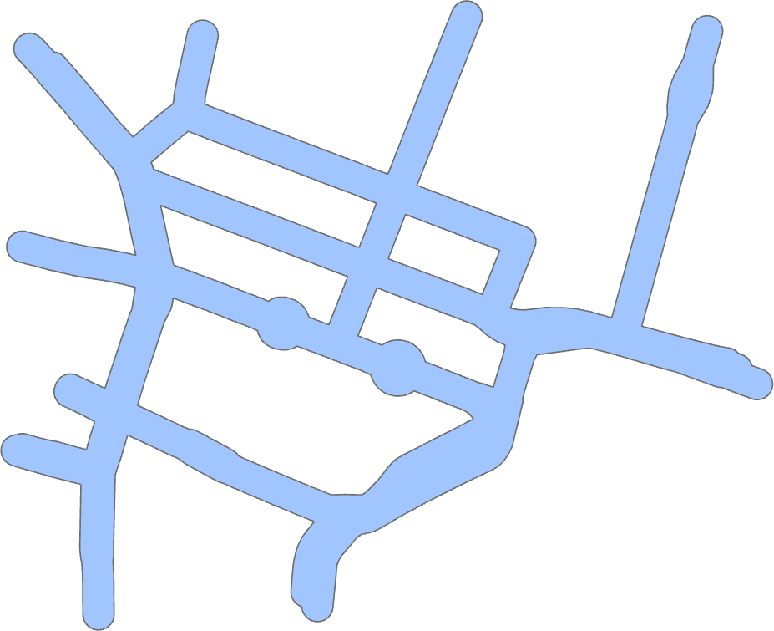

## MULTIPLE RING BUFFER ANALYSIS

Multiple Ring Buffer Analysis creates multiple buffers at specified distances around the input features. These buffers can optionally be merged and dissolved using the buffer distance values to create non-overlapping buffers.

* The task is to create buffers of varying distances around the underground stations. This results into a simple reachability analysis.

1. Search in the *Geoprocessing* pane for the *Multiple Ring Buffer* tool and open it.
2. SELECT *underground_stations* as *Input Feature* and CHOOSE a name and folder for the *Output Feature Class.*
3. TYPE in four increasing distances using the *Add another* button. Namely 250, 500, 750, and 1000 in the *Distances* field. Set the *Linear Unit* (or *Buffer Unit*) to *Meters*.
4. *Buffer Distance Field Name* is the name of the field in the output feature class that stores the buffer distance used to create each buffer feature. If no name is specified, the default field name is 'distance'. This field will be of type Double. Leave this default unchanged.
5. The *Dissolve Option* determines if buffers will be dissolved to resemble rings around the input features. With the option *Non-overlapping (rings)* the buffers will be rings around the input features that do not overlap (think of these as rings or donuts around the input features). The option *Overlapping (disks)* lets all buffer areas to be maintained regardless of overlap. Each buffer will cover its input feature plus the area of any smaller buffers. As we want rings, SELECT the *Non-overlapping (rings)* *Dissolve* *Option*.
6. Again, SELECT the *Planar* method.
7. CLICK *Run* to execute the tool.

* The output multiple buffer rings should have a circular shape (when applying a constant radius). In general, the analysis tools should be calculating using the projection defined in the map properties. However, ArcGIS Pro (of some versions) calculates sometimes spatial distances based on the output layer (this seems to be a bug). In this case, the buffer radius is based on the geographic coordinate system WGS 84 (not on the projected UTM coordinate system). The multiple ring buffers become distorted.

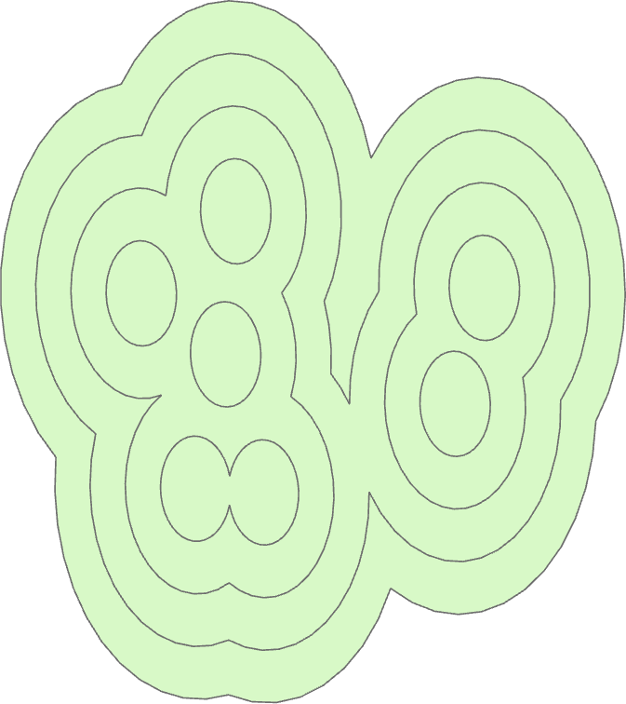

* When the output multiple buffer rings look as in the top figure we can re-project the input layer in order to prevent the buffer distortions. In this case, follow this workflow:

1. Search in the *Geoprocessing* pane for the *Project* tool and CLICK to open it.
2. SELECT *underground_stations* as the *Input Dataset or Feature Class* and CHOOSE a name and folder for the *Output Dataset or Feature Class.*
3. Under *Output Coordinate System* SELECT *Current Map [Map]* to re-project the layer to the map´s UTM 32 N projection zone.
4. *CLICK* to Run the tool. The layer is now not only projected on-the-fly. A simple transformation has been applied to the layer. (This will not meet geodetic engineering requirements, but it is ok for cartographic depiction in this scale.)

* As 2nd task, create Multiple Ring Buffers of varying distances around the *tram_stops* layer. Use the same distances and settings as in 4.3. Check again if the buffers are circular. If they are distorted, repeat the re-projection for the *tram_stops* layer.

## INTERSECT ANALYSIS

Intersect analysis computes a geometric intersection of all input features. *Intersection* is hereby equal to the Geoinformation literature´s term *overlapping*. Features or portions of features which overlap in all layers and/or feature classes will be written to the output feature class.

* In this task we want to find areas that have the same distance to either underground stations or tram stops. Identify regions of the same distance (class) between underground stations and tram stops with an Intersect Analysis.

1. Search in the *Geoprocessing* pane for the *Intersect* tool and open it.
2. SELECT the multiple ring buffer layers around both, underground stations and tram stops, as *Input Features* and CHOOSE a name and folder for the *Output Feature Class.*
3. SELECT the option *All attributes* as *Attributes To Join*.
4. Take the default settings for the *Output Type* and CLICK *Run*. A new overlapping Feature Class is created.

* Next, we will extract the features of same distance class and copy these features to a new layer.

1. Open the Attribute Table of the new Intersect Output Feature Class.
2. Identify the features of same distance class (the same distance value should appear twice in a row). CLICK to SELECT them while HOLDING DOWN the *Ctrl* button.
3. RIGHT-CLICK on this layer in the *Contents* pane, go to Selection, to CLICK on *Make Layer from Selected Features*.
4. *Toggle off* the visibility of the other Buffer and Multiple Ring Buffer layers, to see the regions of same distance (class) between underground stations and tram stops.

## UNION

* The next step of this lesson is to combine the multiple ring buffers from the underground stations and tram stops reachability analysis.

### Executing a Union

1. Search in the *Geoprocessing* pane for the *Union* tool and open it.
2. SELECT the multiple ring buffer layers around both, underground stations and tram stops, as *Input Features* and CHOOSE the name *Union_Rings* and a folder for the *Output Feature Class.*
3. SELECT the option *All attributes* as *Attributes To Join*.
4. Take the default settings for the *Gaps* and CLICK *Run*. A new combined Feature Class is created.

### Refining the Attributes of the Union Layer

1. Take a look into the *Attribute Table* of the *Union_Rings* layer. It looks like two fields have the same name (distance). Although this applies to its Alias only. Change to the *Fields View* of this layer to change the Alias to *distance_1* in order to prevent mix ups in the coming steps.
2. While in the *Fields View*, add a new field with the name *Ring_distance*. SELECT *Double* as *Data Type*. CLICK to Save the field changes and close the *Fields View*.
3. Back in the Attribute Table you can see that two *OBJECTID_<name>* (or *FID_<name>* ) fields have been added for each of the input feature classes. The -1 values indicate features that did not intersect another input feature.
4. Furthermore, you can see that the value *0* has been given to distance fields that were not intersected. This is a logical error, which has to be amended. Open the *Select BY Attributes* tool to select the *0* values of the *distance* field.
5. On the Attribute Table RIGHT-CLICK on the header of the *distance* field to CLICK *Calculate Field*. In the Calculate Field pane TYPE in 1000 as new value and Run the tool. (Editing these records to the highest overall distance value simplifies our following steps.). CLICK *Clear*  to clear the selection.
6. Repeat Steps 4 and 5 for the *distance_1* field.
7. Next we will copy the overall lowest distance values to the *Ring_distance* field. Open the *Calculate Field* tool for this field. ENTER under *Ring_distance* = min([!distance!, !distance_1!]) as new value and Run the tool. You receive a new field with the minimum distance ring class.

## DISSOLVE

Use the Dissolve tool when you want to aggregate features based on a specified attribute or attributes. In comparison to Union you aggregate the features from a single feature class.

* The combined public transport ring buffers are to be further aggregated using the *dissolve* tool.

1. Search in the *Geoprocessing* pane for the *Dissolve* tool and open it.
2. Make sure You have cleared all previous selections. Otherwise this tool will only apply to selected features.
3. SELECT the *Union_Rings* layer as *Input Feature Class* and CHOOSE the name *Dissolve_Rings* and a folder for the *Output Feature Class.*
4. In the *Dissolve Field* settings SELECT *Ring_distance* as the field that the aggregation will be based on.
5. With the *Statistics Fields* option, you can create numeric fields containing attribute values used to calculate the specified statistic. We will not use this for the current task.
6. CHECK the *Create multipart features* check box. This creates the new ring buffers as multipart features. Multipart features are composed of more than one physical part that only references one set of attributes.
7. Leave the *Unsplit_lines* unchecked and CLICK *Run* to execute the tool. You will see how the geometric structure has simplified. Inspect the multipart feature as 750 m public transport ring buffer (depending on the individual placing of your public transport points).

### Visualizing Public Transport Ring Buffers

* Visualise the distance ring levels with a colour scheme. Change the symbology of the new multiple ring buffer feature class to *Graduated Colours*. This way you can symbolize distant areas different from areas around underground stations.

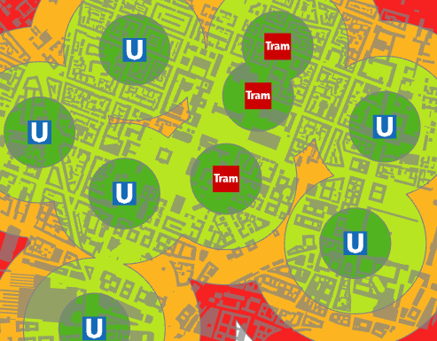

(the geometry of your individual result will probably look slightly different)

## SPATIAL JOIN

This tool is a very helpful and widely used tool in a GIS. It joins attributes from one feature to another based on the spatial relationship. The target features and the joined attributes from the join features are written to the output feature class. A spatial join involves matching rows from the *Join Features* to the *Target Features* based on their relative spatial locations. There are two different join operations that determine how joins between the target features and join features will be if multiple join features are found that have the same spatial relationship with a single target feature.

* Next, we want to use the *main_road_Buffer* layer to determine the buildings overlapping this area by *Spatial Join*. We will save the topologic relation in a new field of the buildings polygon. Then we want to visualize these buildings. Though, we first have to create a field for the buffer that defines an overlap.

### Preparing the Target Data Set

1. Add a text type field to the new *main_road_Buffer* polygon and name it Topology.
2. Edit the new field *Topology* (there should be one record only). TYPE in overlap and save the editing.

### Executing a Spatial Join

1. Search for the *Spatial Join* tool in the *Geoprocessing* pane and open it.
2. We want to Join the *main_road_Buffer* layer attribute to the *buildings* layer (not the other way round). Therefore, SELECT *buildings* as *Target Features* and *main_road_Buffer* as *Join Features*.
3. SELECT a *Join Operation*. As we have only one target feature, this setting has no effect on the result. (The difference is that when multiple join features are found with a single target feature, if “Join one to one” is selected, the attributes from the multiple join features will be aggregated, while if “Join one to many” is selected, multiple copies of the target feature will be made.)
4. CHECK *Keep All Target Features* to receive all buildings in the output layer.
5. SELECT *Intersect* as *Match Option*. Hereby, a join polygon is matched to a target polygon that intersects the boundary or is inside of. This is equal to the Geoinformation literature´s term *overlap*.
6. The *Field Map* under *Fields* controls what attribute fields will be in the output feature class. The initial list contains all the fields from both the target features and the join features. Fields can be added, deleted, renamed, or have their properties changed. Here You can remove some fields such as *Shape_Length* or *Shape_Area*. These are specific attributes for the Buffer layer and not needed for the building output layer. Leave the *Attribute Matching* settings unchanged.
7. CLICK *Run* to execute and create the new spatial join layer.

* Overview of spatial joins for feature type polygons in ArcGIS Pro:

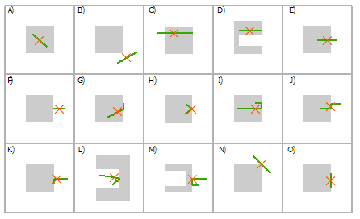

|  |  |
| --- | --- |
| Select line using polygon table | |
| Intersect | A, C, D, E, F, G, H, I, J, K, L, M, N, O |
| Within | A, D, G, H, I, O |
| Contains | A |
| Within Clementini | A, D, G, H, I |
| Boundary touches | F, G, H, I, K, L, M, N, O |
| Share a line segment with | G, I, J, K, M, O |
| Crossed by the outline of | C, E, H, L, N |
| Have their center in | A, C, D, E, G, H, I, J, O |

### Visualizing Overlapped Features

* Show the buildings that are likely to be affected by greater traffic noise. Change the symbology of the new spatially joined buildings layer to unique values and symbolise based on the *Topology* field. This way you can symbolize all buildings with the Buffer attribute *overlap* differently from the *Null* values.

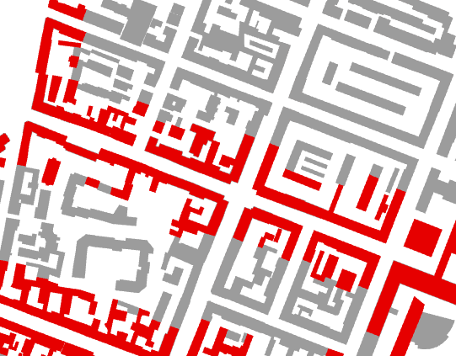

## DISTANCE ANALYSIS

The *Near* tool calculates distance and additional proximity information between the input features and the closest feature in another layer or feature class. This tool can calculate distances between all combinations of geometrical primitives (point, line, and polygon). The distance between any two features is calculated as the shortest separation between them, that is, where the two features are closest to each other

* Use the *Near* tool to calculate distances from every building to a café.

1. Search in the *Geoprocessing* pane for the *Near* tool and open it.
2. Make sure You have cleared all previous selections. Otherwise, this tool will only apply to selected features.
3. SELECT the *buildings* layer as *Input Features* and SELECT the *cafes* layer as *Near Features*.
4. Search Radius defines the radius used to search for near features. If no value is specified, all near features are considered. Here, we can leave the settings on no value.
5. *Location* and *Angle* can be kept unchecked. If these are checked, this specifies and calculates the location to the nearest feature and its corresponding angle.
6. SELECT the Planar Method. As we have a projected coordinate system for this map, Euclidean buffers will be created (as in 4.2).
7. CLICK *Run* to execute. The feature ID of the nearest feature (café), as well as the distance, are added as new fields in the *buildings* attribute table.

## JOINING ATTRIBUTES FROM A TABLE

Joins are not only based on spatial location (4.7), you can join the attribute tables of two features based on their attribute data. Through a common field, known as a key, you can associate records in one table with records in another table.

Typically, you'll join a table of data to a layer based on the value of a field that can be found in both tables. The name of the field does not have to be the same, but the data type must be the same; you join numbers to numbers, strings to strings, and so on. When performing an attribute join, the joined fields are dynamically added to the existing table.

* Enrich the attribute table of the buildings layer, so it shows which café (by café name) is the nearest. Increase the calculating performance by assigning an index. Give the field holding this information an understandable name.

### Starting the Add Join Tool

1. RIGHT-CLICK on *buildings* in the *Contents* pane and CLICK *Joins and Relates > Add Join* to open the *Add Join* tool. (You can also access this tool by the *Geoprocessing* pane.)

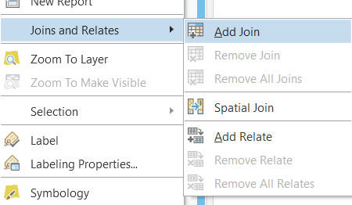

1. SELECT *buildings* for input as *Layer Name*.
2. CLICK to select *Near_FID* as *Input Join Field*.
3. 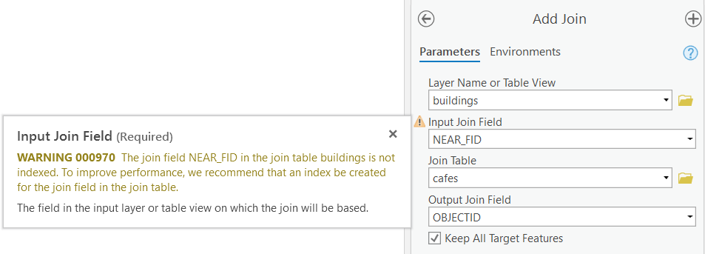HOVER with the mouse-cursor on the warning symbol next to the *Input Join Field.* Currently the new field *Near_FID* has no attribute index. We will add an index in the following task.

### Adding Indices

An index is a data structure that improves the speed of operations on feature class. Indices can be created using one or more columns of a database table, providing the basis for both rapid random look ups and efficient access of ordered records. (See the lectures for more general information on indexing). ArcGIS Pro uses indexes to quickly locate data. Attribute indexes are used to locate records that match an attribute query, and spatial indexes are used to locate features that match a spatial query.

1. Search in the *Geoprocessing* pane for the *Add Attribute Index* tool and open it.
2. SELECT the *buildings* layer as *Input Table*.
3. SELECT from the dropdown arrow menu the *Near_FID* field.
4. ENTER the name Near_Index to the *Index Name* field (any name would work)
5. CLICK *Run* to add the attribute index.

### Completing the Add Join Tool

1. Go back to the *Add Join* tool (see 4.9.1).
2. RESELECT *buildings* for input as *Layer Name*. (The input table is updated to contain the fields from the join table.)
3. CLICK to select *Near_FID* as *Input Join Field*.
4. SELECT *cafés* as *Join Table*, as the table to be joined is the *cafés* layer.
5. CHOOSE *OBJECTID* (or *FID when from shapefile*) from the dropdown arrow menu as *Join Field*.
6. CHECK the *Keep all input records* option. This ensures that also the field with the café´s names is transferred to the *buildings* layer.
7. CLICK *Run* to execute the tool. All fields of the *cafes* layer have been joined to those of the *buildings* layer.
8. Open the *Fields View* for the attribute table of the buildings layer. You will see that we have accumulated many fields for this layer, which is getting a little confusing. TOGGLE OFF the visibility of all the fields starting with *cafes,* except the field *café.name*. This field features the name of the nearest café.
9. Add a field to the attribute table of the *buildings* layer. Name it *NearCafé* with the Alias *Nearest_Café*. The *Data Type* should be set to *Text*. Save Your field changes.
10. Copy the attribute information from the field *café.name* to *NearCafé* (see Lesson 1 for help). This will describe this field´s information much better.

## SPATIAL AUTOCORRELATION

Spatial autocorrelation is a measure of similarity between nearby observations. If there is any systematic pattern in the spatial distribution of a variable X, it is said to be spatially autocorrelated. Moran’s index is a popular spatial autocorrelation measure.

* Calculate Moran´s Index for the spatial distribution of cafés.

The Moran´s Index needs polygons as input in ArcGIS Pro. Therefore, we will use the building layer:

1. Execute a *Spatial Join* (like in 4.7.2.) to count the number of *cafés* each *building* contains.
2. Open the *Spatial Autocorrelation (Global Moran's I) geoprocessing Tool*, take the joined buildings as input, use the *Join_Count* of *Cafés* as *Input Field* (as variable X), and run with the *Inverse distance as* the Conceptualization of Spatial Relationships ( if applicable, choose *Euclidean* as the Distance Method).
3. In the *View Details* window, You will receive the Moran's Index value. The *p-value* gives You details on the significance of the result. The *z-score* is a standard deviation.

## GENERATING A NEAR TABLE

The *Generate Near Table* tool calculates distances and other proximity information between features in one or more feature class or layer. Unlike the *Near* tool, which modifies the input, Generate Near Table writes results to a new stand-alone table and supports finding more than one near feature.

* Calculate distances and directions from every café to its next two public transport points. Furthermore, visualize the café connections to the nearest two public transport points.

### Creating the Generate Near Table

1. Search in the *Geoprocessing* pane for the *Generate Near Table* tool and open it.
2. SELECT *cafes* as *Input Feature*.
3. Beside *Near Features*, use the dropdown arrow menu to SELECT the layers *underground_stations*, *tram_stops* and *bus_stops*.
4. CHECK the *Location* option and CLICK to UNCHECK the *Find only closest feature* option. As we want to find the next two public transport points, TYPE in 2 into the field of this option.
5. The *Search Radius* can be left on the default. The calculating *Method* does not really influence the result in these small distances.
6. CLICK *Run* to generate the table. You will find the table in the *Contents* pane under *Standalone* Tables. View the result.

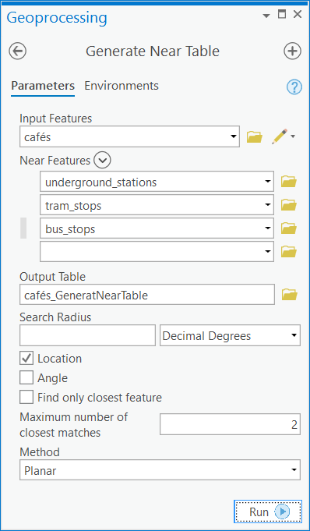

### Visualizing the Connections

1. Search in the *Geoprocessing* pane for the *XY To Line* tool and open it.
2. SELECT the generated Near tableas *Input Feature* and CHOOSE a name and folder for the *Output Feature Class.*
3. SELECT the following settings:
   1. FROM_X as Start X Field,
   2. FROM_Y as Start Y Field,
   3. NEAR_X as END X Field, and
   4. NEAR_Y as END Y Field,
4. The default Line Type Geodesic is fine. Leave the other default settings unchanged.
5. CLICK *Run* to generate a new feature class containing the lines between nearest connections.

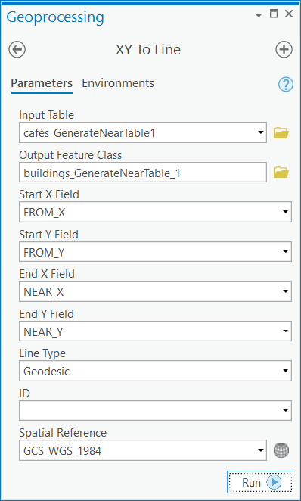

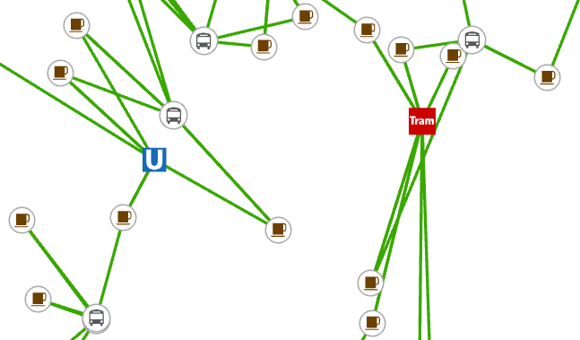

**Contents**

Lesson 4 – Spatial Analysis Methods 1

4.1 THIESSEN POLYGONS 1

4.2 BUFFER ANALYSIS 2

4.3 MULTIPLE RING BUFFER ANALYSIS 3

4.4 INTERSECT ANALYSIS 5

4.5 UNION 7

4.5.1 Executing a Union 7

4.5.2 Refining the Attributes of the Union Layer 7

4.6 DISSOLVE 8

4.6.1 Visualizing Public Transport Ring Buffers 8

4.7 SPATIAL JOIN 9

4.7.1 Preparing the Target Data Set 9

4.7.2 Executing a Spatial Join 9

4.7.3 Visualizing Overlapped Features 11

4.8 DISTANCE ANALYSIS 11

4.9 JOINING ATTRIBUTES FROM A TABLE 12

4.9.1 Starting the Add Join Tool 12

4.9.2 Adding Indices 13

4.9.3 Completing the Add Join Tool 13

4.10 SPATIAL AUTOCORRELATION 14

4.11 GENERATING A NEAR TABLE 15

4.11.1 Creating the Generate Near Table 15

4.11.2 Visualizing the Connections 16